**QR Codes**

Getting your iPod Touch ready to work with QR Codes:

[](http://www.google.com/imgres?imgurl=http://www.callingallgeeks.org/wp-content/uploads/2011/03/app_store_icon1.jpg&imgrefurl=http://www.callingallgeeks.org/22535/how-to-get-refund-for-iphone-app-purchased-accidentally/&h=228&w=229&sz=10&tbnid=AoDeQUg-2N9NIM:&tbnh=90&tbnw=90&prev=/search?q=itunes+store+icon&tbm=isch&tbo=u&zoom=1&q=itunes+store+icon&usg=__U7ZwZkNMfui6msnnub8qZBLv6rI=&docid=czi6s1H32EtBNM&hl=en&sa=X&ei=OnLoT6OfDuf30gHN1Nm-CQ&ved=0CFwQ9QEwAA&dur=1475) Download Red Laser to your iPod Touch.

* Access the iTunes App Store on your iPod Touch
* Click on the Search Tab
* Search for “Red Laser”
* Select the Red Laser Barcode Scanner App
* Select the blue Free button, it should become a green Install button
* Click that green button, and enter your iTunes password (if needed).

To Scan a bar code:

* Open the Red Laser App
* Select the red icon, at the top right of the screen, that looks like this: [||||]
* Aim your phone at a QR Code

Question

Why do polar bears never eat penguins?

Record your answer here, and then check using the qr code at the left!

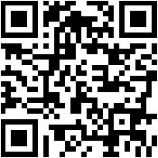

Use the following websites to create QR Codes:

goqr.me qrcode.kaywa.com www.qr-code-generator.com

The lanyard

Scan the QR code with your smart phone code reader to hear the Collins Reading “The Lanyard”

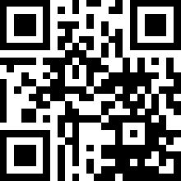The other day as I was ricocheting slowly  
off the blue walls of this room  
bouncing from typewriter to piano  
from bookshelf to an envelope lying on the floor,  
I found myself in the "L" section of the dictionary  
where my eyes fell upon the word, Lanyard.   
No cookie nibbled by a French novelist  
could send one more suddenly into the past.  
A past where I sat at a workbench  
at a camp by a deep Adirondack lake   
learning how to braid thin plastic strips into a lanyard.   
A gift for my mother.  
I had never seen anyone use a lanyard.   
Or wear one, if that’s what you did with them.   
But that did not keep me from crossing strand over strand   
again and again until I had made a boxy, red and white lanyard for my mother.   
She gave me life and milk from her breasts,   
and I gave her a lanyard   
She nursed me in many a sick room,   
lifted teaspoons of medicine to my lips,   
set cold facecloths on my forehead  
then led me out into the airy light  
and taught me to walk and swim and I in turn presented her with a lanyard.   
"Here are thousands of meals" she said,   
"and here is clothing and a good education."   
"And here is your lanyard," I replied,  
"which I made with a little help from a counselor."   
"Here is a breathing body and a beating heart,   
strong legs, bones and teeth and two clear eyes to read the world." she whispered.  
"And here," I said, "is the lanyard I made at camp."  
"And here," I wish to say to her now,   
"is a smaller gift. Not the archaic truth,   
that you can never repay your mother,   
but the rueful admission that when she took the two-toned lanyard from my hands,  
I was as sure as a boy could be   
that this useless worthless thing I wove out of boredom   
would be enough to make us even."

*-- Billy Collins*

Collins, Billy. “The Lanyard.” *Gratefulness.org Poetry Page*. Biron, Dale, et al. n. d. Web. 29 May 2014.

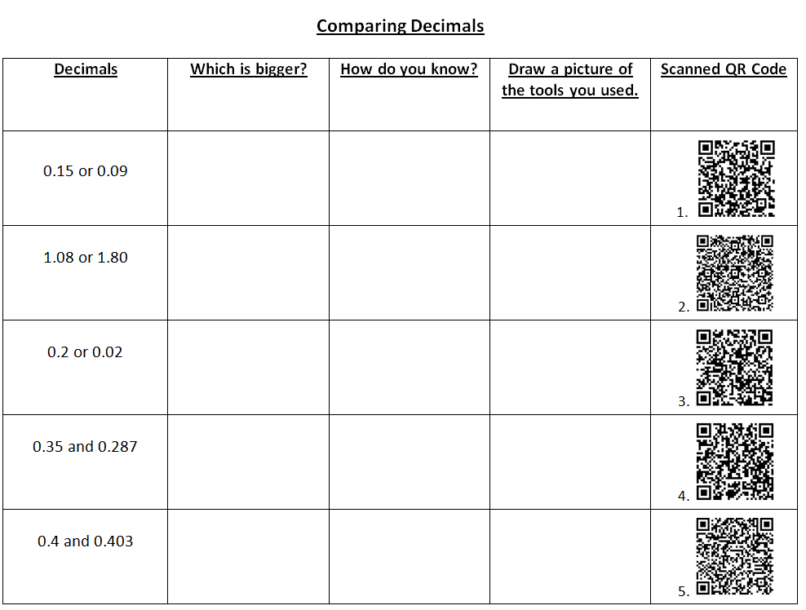

**Translating to an Algebraic Expression:**

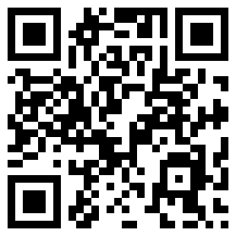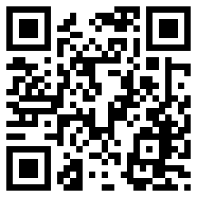Translate each of the following to an algebraic Expression. Access the QR Codes below for help!

**MAT 085 Unit 1 Test NAME:_____________________________________________________**

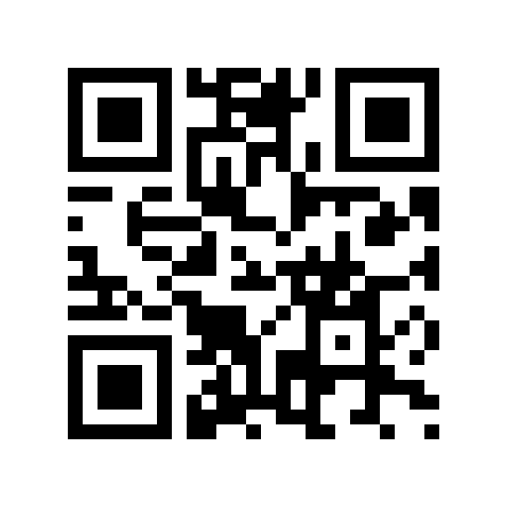**Write out complete solutions to each of the following. 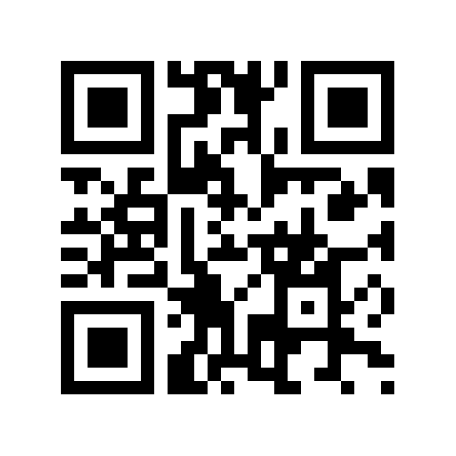 Represent all equations in slope-intercept form unless another form is specified.**

1. 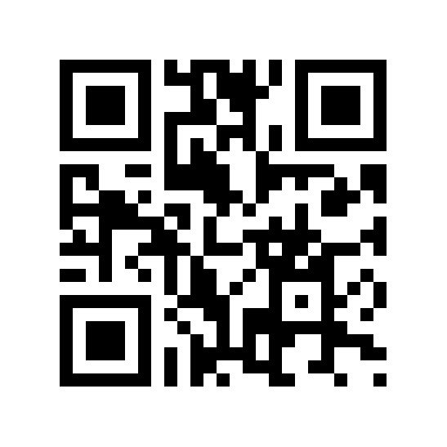Write the equation for the line which passes through (4,5) and (2,-6).

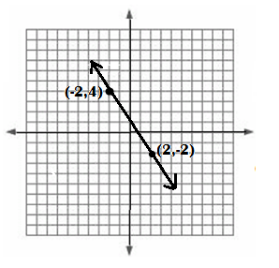 2. 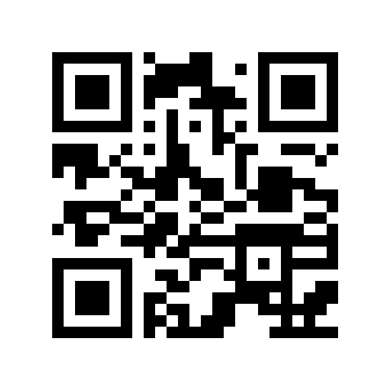 Write the equation of the line shown on the graph:

4. 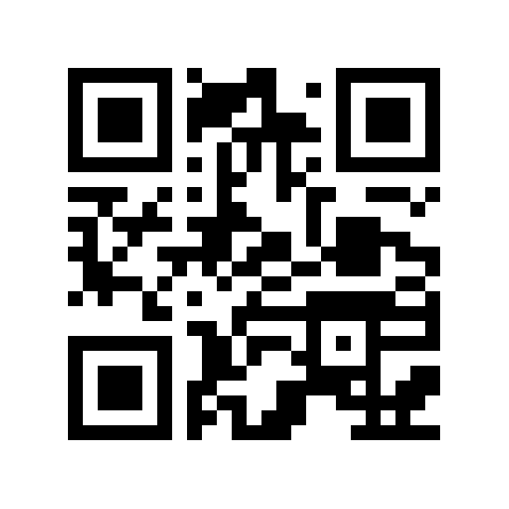Write the equation of the line that has slope -7 and passes through the point (7,5).

